Chapter 7
- Page 351, Problem 90
  - Corrected P7.90
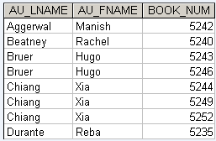

Chapter 8
- Page 427, Table P8.1
  - First and last rows of column DATA DECLARATION should read VARCHAR(15)

